Chapter Five: The Emerging Metropolitan Political Ecology of France
Vincent Hoffmann-Martinot and Jefferey M. Sellers
In France, as in other European countries, the metropolitan transformation poses a challenge to generations of analyses of political behaviour and culture. Through most of the twentieth century, from the analyses of politics under the Third Republic (Siegfried 1913), accounts of territorial influences on voting have centred around either longstanding regional traditions or the divide between urban and rural. At the same time, periurban development has absorbed more and more of the countryside surrounding the largest urban concentrations such as Paris and Lyon, and even smaller regional cities across the country (Julien 2003; Cavailhès et al. 2002; Péguy 2000). A growing majority of the French electorate now lives in extended, interconnected regions divided into localities with distinctive patterns of consumption, employment, social homogeneity and cultural practices (Hoffmann-Martinot 2005). This transformation has immense implications for patterns of electoral participation, and explains much of the new patterns of partisanship that have emerged in France since the 1980s.
In this chapter we examine metropolitan and local sources of the patterns of voter turnout and partisanship that have emerged. The analysis focuses on results at the communal level from the first-round presidential election of 2002, and the first-round results from municipal elections the previous year. As multilevel analyses reveal, the local and metropolitan contexts of voting account for variations in both turnout and partisanship beyond what demographic composition can explain. Interests, values and cultural orientations linked to metropolitan places help to account for the success of the Right in national elections under Jacques Chirac and Nicolas Sarkozy, and the surprise second-place showing of the extreme right under Jean-Marie le Pen in 2002. Similar local and metropolitan influences have shaped turnout in elections at the municipal and national levels, and the relation between them.

French metropolitan areas: demographic and spatial dimensions
Since the 1970s, metropolitan areas in France have grown continuously. In France, state intervention played a direct role in the shaping of mid-century suburbanisation, as the French state directed new development outwards from central cities into high-rise housing estates (grands ensembles) and new cities created in the Paris region (ZUP – Zones à Urbaniser en Priorité). From the 1980s, metropolitanisation proceeded predominantly from private inputs and individual choices. As in the United States, subsidies for homeownership and public programs, such as the construction of new highways, offered incentives for middle class families to move out of the central cities into the urban periphery.
The resulting flight of middle and upper class urban residents from the central cities has departed in significant ways from the U.S. example. From the 1950s, the redevelopment of historical and cultural amenities in French central cities has reinforced their economic drawing power for well-to-do residents. As a result, cross-national comparisons have shown that socio-economic disparities between central cities and their suburbs in France remain more limited than in the US, and that concentrations of disadvantage are often most dramatic in the near suburbs that have built high-rise housing estates (Hoffmann-Martinot 2005). In the metropolitan periphery, following a pattern of ‘rurbanisation’ (Julien 2003; Cavailhès et al. 2002), new housing continues to cluster around the networks of small villages that have long characterised rural France.
New data sources available since 2000, including the first publicly available electronic database with wealth indicators by commune, have made it possible to investigate metropolitan spatial patterns and their electoral consequences systematically. This novel analysis employs a new categorisation of municipalities by the French National Statistical Office (INSEE) that uses commuting and labour market patterns rather than built-up areas to designate metropolitan regions. The resulting 42 ‘urbanised areas’ (aires urbaines) with populations over 200,000 provide the first definitions of metropolitan regions comparable to those in the United States, Canada and other developed countries. In 1999, 77 per cent of the French population lived in these areas, up from 73 per cent in 1990.
The unusual geopolitical fragmentation of French local governments has made municipalities especially helpful units for capturing the variations in political participation and partisan mobilisation within these metropolitan areas. With few exceptions, the boundaries between municipalities have remained fixed since the commune was established as a unit of municipal government in the eighteenth century. Following metropolitanisation, central cities generally encompass only a small proportion of the metropolitan area. The remaining local governments are among the most fragmented in the world (Hoffmann-Martinot 2005). Many communes on the periphery of metropolitan regions number only a few hundred residents, or fewer. These variations ensure that communal ecological data will capture a large portion of the variation in residential contexts within French metropolitan areas, and may even promote patterns of residential sorting that correspond to municipal boundaries.
Despite the particularities of French metropolitanisation, communes in these metropolitan regions sort into types broadly comparable to those in other developed countries. Cluster analysis confirmed the categories from the hierarchical procedure of the IMO protocol. The types consisted of Urban concentrations combine high social hardship and immigrant populations with attraction for higher status groups, housing the second highest proportion (35 per cent) of adult residents with a post-secondary education among the types (Table 5.1).
Table 5.1: Characteristics of town types
Type of commune |  | Population  1999 | Inhabitants  / km² | Post-secondary education (%) | Median income  / person | Home owners (%) | Unemployed (%) | Population born abroad (%) | Workers working  & residing in  same commune (%) | N
Urban concentrations | Mean | 187546 | 3900 | 35 | 9017 | 36 | 18 | 11 | 65 | 50
Urban concentrations | S.d. | 308749 | 2978 | 9 | 1486 | 8 | 4 | 6 | 14
Affluent suburbs | Mean | 6992 | 1407 | 50 | 13575 | 73 | 7 | 10 | 15 | 539
Affluent suburbs | S.d. | 11797 | 3044 | 8 | 1745 | 14 | 2 | 6 | 6
Poor  minority | Mean | 18956 | 2420 | 28 | 8561 | 54 | 16 | 18 | 26 | 331
Poor  minority | S.d. | 20844 | 3149 | 7 | 1454 | 16 | 4 | 5 | 10
Poor non-minority | Mean | 4398 | 558 | 24 | 8438 | 67 | 15 | 6 | 21 | 843
Poor non-minority | S.d. | 6412 | 891 | 8 | 1182 | 15 | 4 | 4 | 9
Middle class suburbs | Mean | 2822 | 354 | 31 | 10135 | 78 | 8 | 6 | 17 | 2298
Middle class suburbs | S.d. | 4361 | 725 | 7 | 1185 | 11 | 2 | 4 | 7
Low density suburbs | Mean | 441 | 35 | 27 | 9152 | 80 | 9 | 5 | 20 | 2713
Low density suburbs | S.d. | 450 | 16 | 9 | 1552 | 9 | 4 | 4 | 9
Total | Mean | 4548 | 463 | 30 | 9760 | 75 | 10 | 6 | 19 | 6774
Total | S.d. | 31609 | 1409 | 10 | 1919 | 13 | 4 | 5 | 10

Low density suburbs, the most numerous type of commune, exemplify the ‘rurbanised’ pattern on the fringe of metropolitan regions. Communes of this type have maintained the high homeownership of agrarian communities, modest average incomes and low percentages of foreigners.
Middle class suburbs, the second largest group of metropolitan communes, have comparatively high average incomes and high rates of commuting. They also retain aspects of traditional village character, including the second lowest population densities, the second highest rate of homeownership and the second lowest proportion of foreign residents.
Poor minority suburbs correspond most closely to the popular image of the French banlieux, with the biggest immigrant concentrations, the lowest average incomes and among them the highest population densities.
Poor non-minority suburbs possess high average unemployment like their more ethnically diverse counterparts, and even lower average income as well as a lower proportion of adults with secondary education. Located largely on the rural metropolitan fringes, however, they exhibit population densities only one-fourth or lower those of poor minority suburbs.
Affluent suburbs are overwhelmingly bedroom suburbs, with 85 per cent of workers commuting outside communal boundaries to work. Predominately located within a short distance of the central city, they possess high homeownership, high rates of post-secondary education, and low unemployment.
Along with broad resemblances to parallel types in North America and other European countries in the process of metropolitanisation, this classification also reflects various patterns of clustering among the demographic indicators used in this analysis. Relations among these variables at the community level evince some of the same correlations that demographic analysis at the individual level has shown. Post-secondary education and median income correlate closely (.76, p<.001). However, ecological relationships between each of these variables and other features of communities suggest divergences that will ultimately be shown to have political consequences. Place-linked characteristics of communities bear more limited relations to these measures of demographic composition. Only the Simpson Index, a three category indicator of economic diversity, manifests correlations higher than .50 with the indicators for income (.70, p<.01) and post-secondary education (.64, p<.01).

Examining the Political Ecology of French Metropolitan Areas
The growth of metropolitan areas into the predominant form of settlement in France has made the characteristics of metropolitan places increasingly decisive both for national patterns of political participation and for national partisan affiliations.
Our analysis of these effects focuses on the Presidential election of April 21, 2002 and the communal elections of March 11, 2001. In each instance, the elections under scrutiny represent the first round of a two-round majoritarian electoral process. The first round of the 2002 Presidential election marked the first of two successive Presidential elections in which the candidate of the Centre-right dominated candidates of the Left, and a high watermark of support for anti-immigrant, ethnonationalist parties on the Right. In the first round of voting Jean-Marie Le Pen of the right-wing National Front unexpectedly edged out Socialist Party candidate Lionel Jospin to win second place in the balloting. Although Le Pen lost decisively in the second round to President Jacques Chirac of the conservative Union for a Presidential Majority (UMP), the first ballot holds special interest as a window on the sources of support for the conservative formations that have dominated French politics since the 1990s and on patterns of electoral mobilisation that contributed to a surge in support for the extreme right. Metropolitan and local influences provide much of the explanation for both of these results.

Election turnout and delocalisation
The data released by the Ministry of the Interior for this study offer a comprehensive overview of election turnout as a proportion of registered voters in metropolitan areas throughout France. Turnout in both national and local elections remained high in low density and middle class suburbs, but averaged lower in urban concentrations and poor minority suburbs. Turnout gaps that fit the pattern of delocalised electoral participation were present in the affluent suburbs and central cities, and in larger metropolitan regions. In the most rural parts of French metropolitan regions, and in certain regions of the country, local turnout still exceeds national turnout. Multilevel statistical analysis allowed these relationships at various levels and the relations among them to be sorted out.
Up until the 2007 presidential election, when national turnout surged, participation of registered voters in French elections had been in decline since the 1970s (Clanché 2003). In the first round of the 2002 presidential elections, the abstention rate of 28.4 per cent represented a historical low for the Fifth Republic. In municipal elections, the decline in turnout has been more continuous, reaching an abstention rate of 32.6 per cent nationwide in 2001 and 33.5 per cent in 2008.
The analysis of this volume, along with an international literature on electoral turnout and a more circumscribed body of research on French voter participation (Hoffmann-Martinot 1992; Blais 1994), points to several clear expected findings about how patterns of turnout are likely to vary between places. The nationally uniform electoral system, the national party system, and the tightly integrated national media in France give reason to anticipate uniform patterns of turnout among localities in both types of elections. If the ecology of communities reflects the individual propensities evident from survey analysis, then the demographic composition of communities should predict participation. Higher participation rates should result from more educated and affluent residents (Dalton 2008: 63), more older residents (Dalton 2008; Niemi and Barkan 1987; Gimpel et al. 2004; Goerres 2005), fewer unemployed residents (Rosenstone 1982) and more native French residents as a proportion of the population (Tiberj 2004).
Contextual predictors of participation have rarely been tested in France. There is ample reason to suspect that the growing population of suburban homeowners, like their counterparts in the United States or Britain, will vote more often (Fischel 2001; Kingston et al. 1984). The ‘decline of community’ argument states that the low density and middle class communes should give rise to stronger solidaristic tendencies and more personal motivation to vote (Verba and Nie 1972; Hoffmann-Martinot 1992; Frandsen 2002). In rural France, local clientelism and village social networks have traditionally fostered high participation rates, particularly in the South (Kesselman 1967; Hoffmann-Martinot, Thrasher and Rallings 1996). Socioeconomic diversity, measured here by the tripartite Simpson Index based on occupational categories, has been shown to promote greater local mobilisation to vote in the United States (Oliver 2000). Various dimensions of social mobility, including the day to day mobility of commuters and frequent changes in residence, can undermine participation as well (Squire et al. 1987; Putnam 2000).
More directly political effects on turnout have received virtually no attention. Either local political competition (Oliver 2000, 2001) or local solidary effects (Bréchon and Cautrès 1987; Campbell 2006) could induce voters to participate more regularly. In small communes, rules for local elections provide additional incentives for participation and voter choice. In communes with populations under 3500, voters may choose individual candidates from the lists of candidates for council seats. In communes with populations under 2500, the lists need not include candidates for every seat and even individual candidacies are permitted. Either rule could encourage stronger ties between voters and individual local candidates, supporting the local mobilisation that has maintained high electoral participation in rural France (Hoffmann-Martinot 1992; Nevers 2002)
The relations between participation in national and local elections have received even less scrutiny. Overall, participation in national elections has generally ranged higher than in local elections (Flanagan 1980; Abrial et al. 2003). The news media and political parties should have stronger nationalising effects in national elections than in local ones. We might also expect the gap between national and local turnout to be greater among affluent communities (Oliver 2001; see Sellers and Walks, this volume), and weaker or even reversed for metropolitan communities that retain rural characteristics.

Overall patterns of election participation
An initial comparison of the turnout in the first round presidential and municipal elections points to a consistently high turnout in the most rurbanised metropolitan communities, and a significant but limited turnout gap in other types. The lowest overall turnout rates and the most significant turnout gaps appear in the most urbanised places and the largest urban regions.
Although both municipal and national elections were administered uniformly across the country, the presidential election clearly mobilised the electorate at more uniform rates. The median turnout for the presidential election was 76.8 per cent, that for municipal elections only slightly lower at 74.9 per cent. In presidential elections, however, turnout diverged much less among metropolitan municipalities. The standard deviation (5.5 per cent) was lower by nearly half of that for the municipal ballot (9.8 per cent). Means for the distinct town types also varied by only ten per cent for the presidential election, compared to 25 per cent for the municipal elections (Figure 5.1)
The town types revealed significant variations across French metropolitan areas in the relation between national and local turnout. The low density communes on the outskirts of metropolitan regions manifested the same intense, localised pattern of participation noted in previous analyses (Hoffmann-Martinot; Nevers 2002). Turnout for both types of elections was highest in these municipalities. Local electoral turnout clearly and consistently exceeded national turnout. In middle class suburbs and poor nonminority suburbs, which shared 'rurbanised' tendencies with the low density suburbs, turnout also proved to be higher than in the remaining types.
Figure 5.1: Turnout in presidential and municipal elections, by type of metropolitan commune
In both the most advantaged and the most disadvantaged communities, and even more in the urban concentrations that harboured both affluence and disadvantage, tendencies toward delocalisation appeared. The gap between national and municipal turnout averaged from 7 per cent in the affluent suburbs and poor minority communities to 13 per cent in the urban concentrations. The main source of these bigger gaps was the fall-off of turnout in municipal elections. Although national turnout rates averaged 12 per cent lower in urban concentrations than in the low density suburbs, turnout in municipal elections averaged 34 per cent lower. A less dramatic gap of 10 per cent in national elections and 13 per cent in municipal elections separated turnout in poor high minority suburbs from the low density suburbs. In affluent suburbs, national election turnout fell off only slightly (1 to 4 per cent) from the averages in low density, middle class, or poor low minority suburbs. However, average municipal election turnout dropped to 13 per cent below the average for high density suburbs, and 5 per cent below the other two types. Despite a more standardised national electoral context than in the United States, these patterns demonstrate a delocalisation of voter participation among affluent, disadvantaged and urbanised communities.
Seventy-five per cent of the variance in presidential turnout and 79 per cent of variance in municipal turnout occurred within metropolitan areas. Comparison of the mean local turnout by metropolitan areas also pointed to systematic regional and metropolitan differences (Figure 5.2).
Figure 5.2: Turnout in presidential and municipal elections, by region and metropolitan population

Studies of French local politics have consistently shown that local participation ranges especially high relative to national participation in the southern regions where clientelism has persisted (Kesselman 1967; Hoffmann-Martinot 2005). Localised participation consistent with this pattern predominates in such metro areas as Pau, Nimes, Perpignan and Bayonne. A similar pattern of high local participation also appears in a number of metropolitan regions along the eastern border with Italy, Switzerland, Germany and Belgium. Clientelism seems less likely as an explanation for the patterns in Annemasse along the Swiss border, or Nancy and Mulhouse in Alsace-Lorraine. The local mobilisation there may derive more from engagement in cross-border issues at the local level, or stronger regional and local identity in these border regions.
Regardless of wider regional differences, local election turnout in the largest French metropolitan area falls below levels elsewhere. The diverse theories that have linked larger urban size to lower participation clearly apply in some combination to this contrast. Local electoral participation is especially low in the biggest metropolitan areas. Two of the four largest – Paris and Lyon – register the lowest metropolitan average rates of local election turnout. Rates for the Lille and Marseille metropolitan areas are the lowest or second lowest in their respective regions.
Ordinary least squares regressions confirmed the lower turnout rates in urban concentrations, affluent suburbs and poor minority suburbs, and the higher turnout in high density suburbs (Table A.5.1 in the Appendix and Table WA.5.1 in the Web Appendix). The town types can account for 29 per cent of the variation in municipal election turnout, but only 14 per cent of the variation in presidential turnout.

Examining multilevel variation
Multivariate analysis enabled examination of the specific sources for the variations among the town types, and a fuller account of the variations. Although ordinary least squares regressions confirmed numerous hypotheses, they did not allow full exploration of the clear regional and metropolitan variations. Hierarchical linear models provided a way to sort out these effects at different scales, and to examine the relations between them. Because multilevel analyses provided the most complete accounts, the discussion will focus on these results.
Models of continuous demographic and contextual variables generally account for much more of the variation in turnout than the town types alone. The complex ecological relationships among these variables made it more helpful to examine alternative models than to base the analysis on a single model (Table 5.2). Alternative models enabled tests of whether the variations in turnout grew out of the demographic composition of municipalities, or can be traced to differences rooted in the metropolitan spatial context of municipalities.

Table 5.2: Presidential election turnout, first round 2002
 | Compositional |  | Contextual |  | Full linear |  | Full randomised
 | B | t | B | t | B | t | B | t
Intercept | 89.09 | 24.14 | 89.01 | 18.69 | 89.08 | 19.00 | 77.64 | 155.20
Metro level
Eastern border region | -0.53 | -1.11 | -0.42 | -0.70 | -0.53 | -0.91 | -0.90 | -1.23
South | 0.93 | 0.94 | 1.01 | 1.10 | 0.92 | 1.02 | -0.72 | -0.86
Post-secondary education | 0.24 | 3.83 | 0.25 | 3.13 | 0.24 | 3.10
Foreign-born | -0.36 | -5.43 | -0.37 | -4.05 | -0.36 | -3.94
Population (log) | -2.96 | -4.61 | -2.95 | -3.29 | -2.96 | -3.36
Cross-level
Post-secondary education |  |  |  |  |  |  | 0.00 | -2.86
Foreign-born |  |  |  |  |  |  | 0.01 | 3.08
Population (log) |  |  |  |  |  |  | -0.71 | -5.67
Local level
Post-secondary education | 0.07 | 4.53 |  |  | 0.06 | 5.14 | 0.18 | 4.34
Foreign born | -0.42 | -7.23 |  |  | -0.17 | -9.62 | -0.24 | -6.83
Age 60 or more | -0.01 | -0.19 |  |  | 0.00 | 0.22 | 0.01 | 0.67
Median income | -.0003 | -2.14 |  |  | -.0003 | -2.68 | -.0003 | -3.24
Unemployment | -0.38 | -7.95 |  |  | -0.24 | -13.11 | -0.25 | -13.19
Homeowners |  |  | 0.05 | 8.83 | 0.03 | 4.14 | 0.02 | 3.25
Noncommuters |  |  | -0.02 | -2.96 | -0.03 | -4.18 | -0.04 | -5.33
Residential stability |  |  | -0.04 | -4.87 | -0.02 | -2.24 | -0.01 | -1.19
Housing after 1975 |  |  | 0.02 | 4.63 | 0.01 | 1.30 | 0.00 | 0.75
Occupantional diversity |  |  | 5.20 | 10.14 | 1.84 | 2.49 | 1.23 | 1.63
Population density (log) |  |  | -2.10 | -14.95 | -1.27 | -8.61 | 3.11 | 3.97
Political diversity |  |  | -0.33 | -6.31 | -0.26 | -4.95 | -0.25 | -4.74
Population 2500-3500 |  |  | 0.63 | 2.43 | 0.55 | 2.39 | 0.51 | 2.20
Population under 2500 |  |  | 1.85 | 9.06 | 1.81 | 9.66 | 1.79 | 9.60
Chi-square |  | 926 |  | 928 |  | 1046 |  | 4854
D.f. (Metropolitan) |  | 36 |  | 36 |  | 36 |  | 39
(Local) |  | 6304 |  | 6766 |  | 6295 |  | 6295
p-value |  | 0 |  | 0.00 |  | 0.00 |  | 0.00
Reliability est. |  | 0.943 |  | 0.94 |  | 0.95 |  | 0.97
Total variance explained |  | 37% |  | 30% |  | 42% |  | 36%
Metro variance explained |  | 43% |  | 41% |  | 42% |  | 1%
Local variance explained |  | 35% |  | 28% |  | 43% |  | 43%
Estimator |  | -1.75 |  | -1.91 |  | -1.72 |  | -1.71
Notes: For boldface coefficients, p<.05.

Metropolitan level contextual variables include dichotomous indicators for the southern and eastern border regions, along with the significant variables that emerged from a backwards regression with the full array of communal level variables. A combined model tested these compositional and contextual variables alongside each other. Finally, multilevel analysis with randomised variables at the metropolitan and regional levels permitted closer examination of the often complex relationships between local and metropolitan variations.
Both the contextual and the compositional variables explain significant portions of the variation in Presidential election turnout. In hierarchical linear models which included the metropolitan context, a spatial contextual model of Presidential election turnout accounted for nearly as much of the local variance as a compositional model (28 per cent compared to 35 per cent). The combination of these contextual variables with compositional ones explained 8 per cent or more local variance than in either separate model, for a total of 43 per cent.
The compositional variables generally performed consistent with established hypotheses, but several had metropolitan as well as local effects. As expected, more adult residents with higher education led to higher turnout. More local residents born abroad brought about lower turnout. Ordinary least squares regressions showed that parallel effects at the metropolitan level accompanied each of these local effects (see Table WA.5.1). Multilevel analysis demonstrates a relationship between the communal and metropolitan variations. In metropolitan areas with more educated adult residents or more residents born abroad, the local effects from both education and foreign-born populations proved significantly stronger. When levels of education were controlled, the median income of a community proved to be a significant predictor of lower rather than higher turnout at both local and metropolitan scales. Multilevel analysis confirmed that the comparatively low presidential turnout in affluent suburbs was part of a wider disengagement among higher income regions that had contributed to the breakthrough of Le Pen in the 2002 Presidential first round election.
The models affirm the importance of several contextual variables. In both the multilevel and the ordinary least squares models, local population density emerged as one of the strongest predictors of lower turnout (in the full hierarchical linear model, B=-1.27, p<.001). Metropolitan size compounds this effect (p<.01). More homeownership corresponded to significantly higher turnout even with the demographic variables included (B=.03, p<.01). When demographic variables were controlled, occupational heterogeneity had a stronger but more volatile positive effect (B=1.84, p<.05).
Other dimensions of the local context had surprising effects contrary to our expectations. Work on social capital from the United States suggests commuting or residential mobility should lead to higher voting turnout (e.g. Putnam 2000). In France, rather than undermine engagement in national politics, both commuting and residential mobility are in fact linked to higher levels of participation (in the full model, B=-.03, p<.01, and B=-.02, p<.01, respectively). Although suggested in some of the Swedish results (Lidström 2005; see Kübler and Bäck in this volume), this unusual finding may be linked to the extraordinary fragmentation of French metropolitan communes. Where metropolitan residents rarely live and work in the same municipality, mobility appears to have engaged citizens to participate more actively in elections.
Local political dynamics and the institutional conditions of communal elections also make a significant difference in national turnout rates. Social diversity, as measured by the Simpson Index, tends to promote turnout (B=1.84, p<.05). Political diversity, on the other hand, has an opposite effect. The less fragmented the local party landscape, as measured by the Laakso-Taagapera Index (Laakso and Taagepara 1979), the stronger the national electoral turnout (in the full model, B=-.26, p<.01). Solidaristic dynamics rather than competitive ones drive participation rates. The local election rules that give local voters in the smallest communes more choice in their selection of candidates also promote higher turnout rates in national elections. Communes with populations from 2500 to 3500 turn out significantly more than other places in national elections (B=.55, p<.05). This relationship is even stronger for communes with populations under 2500 (B=1.18, p<.001).
Final models with randomised metropolitan and regional variables enabled more detailed exploration of how the multilevel local effects differ by metropolitan regions (Table 5.2). By allowing the slopes of the regression lines for each metropolitan area to vary, this model shows that the effects of higher education on turnout differ in several of the metropolitan regions with the highest overall levels of education (Figure 5.3(a)). Within such metropolitan regions as Toulouse, Rennes and Grenoble, where higher educated residents have clustered, a metropolitan effect from an educated electorate boosts turnout across the board. Within these metropolitan areas, higher education makes significantly less difference for national election turnout than elsewhere. A similar flattening of municipal differences takes place in the metropolitan areas with more foreign-born residents (Figure 5.3(b)). In a number of the metropolitan regions with the highest proportions of foreign-born residents, for example, Lille, Nice, and Annemasse on the Swiss border, larger numbers of residents born abroad make less of a difference for turnout at the local level than in other metropolitan areas. Finally, municipal population density has a more negative effect on national turnout in the largest metropolitan regions (Figure 5.3(c)). This effect may simply reflect the greater range of density in these settings. It may also be traced back to the solidary dynamics of small metropolitan communities more exposed to national media and party campaigns than in peripheral regions.
The same models are even more effective in accounting for municipal election turnout. The hierarchical linear models account for up to 53 per cent of the local variance in municipal election turnout, along with 48 per cent of the variance between metropolitan areas. In these elections, metropolitan and local spatial contexts clearly matter more for turnout than the demographic composition of localities. Although the town types alone account for 1 per cent more of the variation in municipal turnout in the ordinary least squares models than the compositional variables (29 per cent, as opposed to 28 per cent), the contextual and full models account for twenty to 27 per cent more.
In the multilevel analysis, the contextual model explains 49 per cent of the variation compared to 35 per cent for the compositional model (Table 5.3). Numerous individual contextual variables bear a stronger relationship to municipal turnout than to presidential turnout, including homeownership (B= .05, p<.01), density (B= -5.37, p<.001), and local political homogeneity (B= -.62, p<.001).
Although both commuting and residential stability exert similar effects to those in national elections, a third indicator of ties to local communities now demonstrates the expected effect. Larger proportions of new housing in a community emerge as a significant predictor of lower municipal election turnout (B= -.04, p<.01).

Figure 5.3: Metropolitan variations in effects on presidential election turnout (randomised slopes by metropolitan area)
a) Education, by communes and metropolitan areas
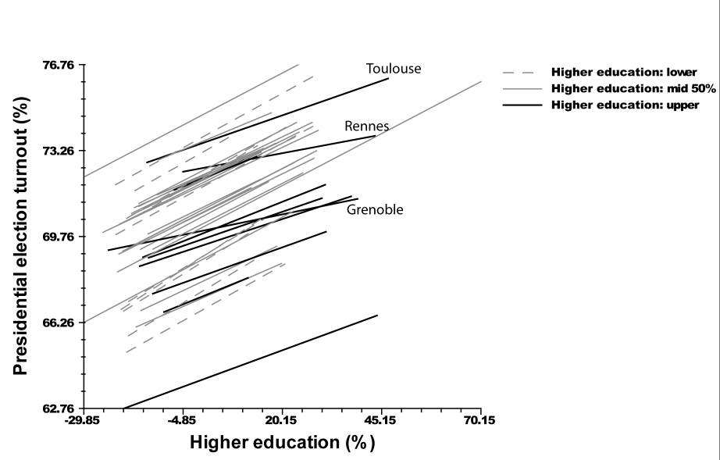

b) Residents born abroad, by communes and metropolitan areas
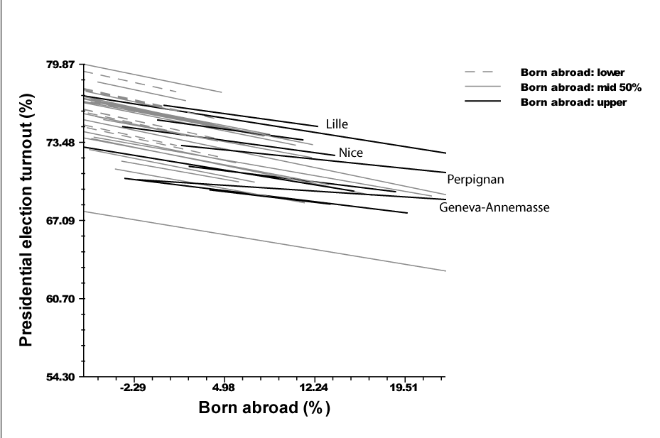

c) Population density by commune and population by metropolitan area
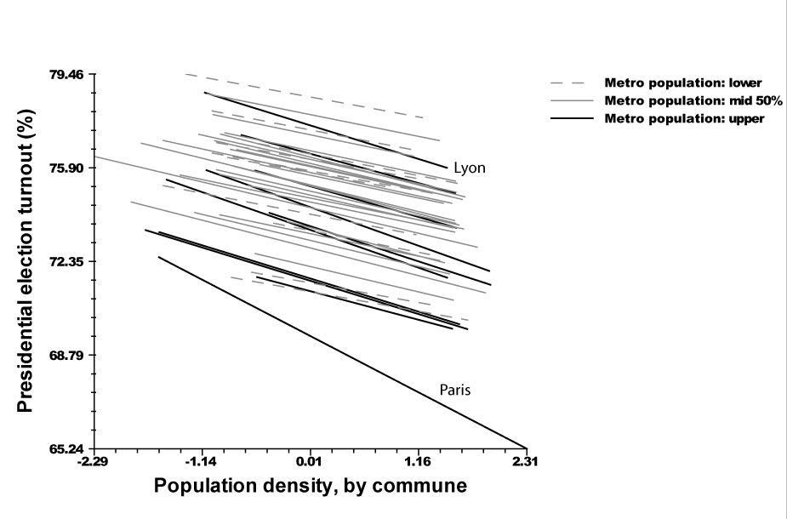
Table 5.3: Municipal election turnout, first round 2001
 | Compositional |  | Contextual |  | Full linear |  | Full randomised |  | Final randomised
 | B | t | B | t | B | t | B | t | B | t
Intercept | 99.47 | 12.94 | 99.53 | 12.79 | 99.53 | 12.92 | 73.38 | 103.36 | 73.77 | 90.78
Metro level
Eastern border region | 1.59 | 1.75 | 2.08 | 1.95 | 1.59 | 1.63 | 1.21 | 1.02 | 1.21 | 1.02
South | 5.98 | 4.82 | 6.19 | 3.81 | 5.96 | 3.99 | 2.66 | 1.98 | 2.67 | 1.98
Post-secondary education | -0.02 | -0.19 | -0.01 | -0.07 | -0.02 | -0.14
Foreign-born | -0.43 | -3.29 | -0.46 | -2.81 | -0.43 | -2.88
Population (log) | -4.14 | -3.23 | -4.10 | -2.57 | -4.16 | -2.85
Cross-level
Post-secondary education |  |  |  |  |  |  | 0.01 | 2.77 | 0.01 | 2.80
Foreign-born |  |  |  |  |  |  | 0.00 | 0.10
Population (log) |  |  |  |  |  |  | 1.74 | 8.48 | 1.74 | 8.48
Local level
Post-secondary education | 0.03 | 1.04 |  |  | 0.06 | 3.14 | -0.15 | -2.13 | -0.15 | -2.16
Foreign born | -0.95 | -11.39 |  |  | -0.22 | -7.53 | -0.27 | -4.60 | -0.26 | -9.07
Age 60 or more | 0.17 | 5.46 |  |  | 0.04 | 1.71 | 0.02 | 0.96 | 0.02 | 0.97
Median income | -.001 | -6.65 |  |  | -.001 | -6.05 | -.0005 | -4.39 | -.0005 | -4.93
Unemployment | -0.64 | -6.27 |  |  | -0.30 | -9.96 | -0.27 | -8.67 | -0.27 | -8.73
Homeowners |  |  | 0.09 | 9.01 | 0.05 | 4.99 | 0.06 | 5.80 | 0.06 | 5.83
Noncommuters |  |  | -0.03 | -2.42 | -0.05 | -4.49 | 0.01 | -2.90 | -0.03 | -2.90
Residential stability |  |  | -0.05 | -4.73 | -0.03 | -2.30 | -0.05 | -3.70 | -0.05 | -3.70
Housing after 1975 |  |  | -0.03 | -5.23 | -0.04 | -5.29 | -0.37 | -4.65 | -0.04 | -4.65
Occupational diversity |  |  | -3.57 | -4.53 | -4.11 | -3.36 | -2.94 | -2.36 | -2.93 | -2.36
Population density (log) |  |  | -6.70 | -31.02 | -5.37 | -21.93 | -16.05 | -12.43 | -16.07 | -12.43
Political diversity |  |  | -0.64 | -8.00 | -0.62 | -7.07 | -0.65 | -7.48 | -0.07 | -7.48
Population 2500-3500 |  |  | 0.42 | 1.07 | 0.38 | 0.98 | 0.40 | 1.06 | 0.41 | 1.06
Population under 2500 |  |  | 3.67 | 11.66 | 3.61 | 11.63 | 3.58 | 11.62 | 3.58 | 11.64
Chi-square |  | 888 |  | 1468 |  | 1206 |  | 2537 |  | 2549
D.f. (Metropolitan) |  | 36 |  | 36 |  | 36 |  | 39 |  | 39
(Local) |  | 6304 |  | 6768 |  | 6297 |  | 6297 |  | 6299
p-value |  | 0 |  | 0.00 |  | 0.00 |  | 0.00 |  | 0.00
Reliability est. |  | 0.931 |  | 0.96 |  | 0.95 |  | 0.97 |  | 0.97
Total variance explained |  | 37% |  | 48% |  | 52% |  | 47% |  | 47%
Metro variance explained |  | 49% |  | 38% |  | 48% |  | 14% |  | 14%
Local variance explained |  | 35% |  | 49% |  | 53% |  | 54% |  | 54%
Estimator |  | -2.13 |  | -2.21 |  | -2.03 |  | -2.03 |  | -2.03
Notes: For boldface coefficients, p<.05.

The compositional variables still account for the same overall proportion of the local variance as in the presidential election, and add four per cent to the variance explained in a full linear model. With all other influences controlled, higher income communities voted even less consistently in municipal elections than in presidential elections (p<.001 compared to p<.05). Two indicators that generally correspond to concentrated disadvantage, foreign-born residents (B= -.22, p<.001) and unemployment rates (B= -.30, p<.001), also contribute more strongly and consistently to lower municipal turnout than in the presidential election. Higher education retains a positive influence on local turnout (B= .06, p<.05), but only at the local level; at the metropolitan level this variable has no significant influence.
Regional and metropolitan influences affect municipal turnout more consistently than presidential turnout. In contrast with presidential voting, regional variations retain their significance regardless of the other variables included. Local turnout in the southern region remains markedly higher than elsewhere across the entire range of models (p<.01). The eastern border region also exhibits higher turnout (p<.10) except in the models with randomised metropolitan predictors.
As randomised models demonstrate, the directions as well as the strength of local effects are closely linked to metropolitan and regional differences. In several respects the cross-level effects are the opposite of those for presidential election turnout. The community effects from higher education differ among metropolitan areas with different levels of education. In the metropolitan areas with the greatest concentrations of more educated residents, local milieus of intensified voter mobilisation produce higher municipal turnout rates (Figure 5.4(a)). In the metropolitan areas of Grenoble, Rennes and Toulouse, the local turnout in the most educated municipalities is more pronounced than in other metropolitan regions. In these same metropolitan settings, local presidential election turnout rates were more uniform than in the other metropolitan regions. In several metropolitan areas with overall low levels of higher education, the most educated communities turn out less frequently in municipal elections.
Metropolitan size had contrary cross-level effects in the municipal election from those in the presidential election (Figure 5.4(b)). The demobilising effects of the most massive French metropolitan concentrations appeared to overshadow the local effects from the decline of community with rising population density in individual metropolitan towns. Particularly in metropolitan Paris, municipal turnout not only averaged lower than anywhere else, but declined less with rising density. In the national election, lower density had a stronger mobilising effect in metropolitan areas like Paris and Lyon than elsewhere.
The turnout gap between the presidential and local elections thus derives from an interrelated assortment of institutional, local and metropolitan effects (Table 5.4). Contextual variables have the biggest delocalising effects. They explain a third of the overall variation in the differential between Presidential and municipal election turnout, and when added to the demographic model account for 13 per cent more. Two variables directly linked to urbanised concentrations, population density (B= 4.09, p<.001) and occupational diversity (B= 5.95, p<.001) exert the strongest impact on delocalisation. Local political diversity, based on party performance in the Presidential election, also contributes significantly to the turnout gap (B= .36, p<.001), so does new housing (B= .05, p<.01). The distinctive electoral rules and practices of the smallest communes limit the gap (B=-1.80, p<.001), as does homeownership (B= -.03, p<.05). The southern and eastern border regions also mobilised more consistently in elections at both levels.
Figure 5.4: Muncipal turnout rates, by commune and by metropolitan area (randomised slopes by metropolitan areas)
a) Higher education by commune and metropolitan area
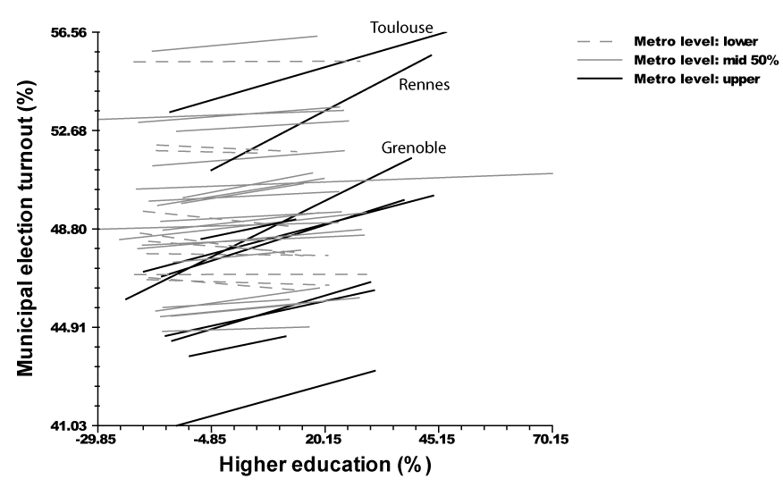

b) Population density by communal population, and by metropolitan population
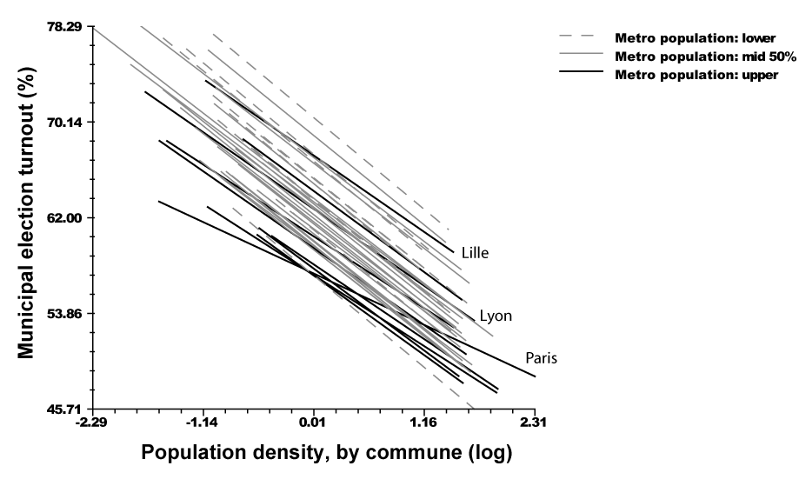

The most consistent demographic source of delocalised participation is socioeconomic privilege in a community. The distinct effects from higher education and median income reveal significant variations in these influences. Metropolitan communities with higher median incomes generally mobilised more in the presidential election than in the municipal election (B= .0004, p<.001). Higher education fostered delocalisation consistently at a metropolitan scale (p<.05), but not at a local scale. As randomised variables demonstrated, the turnout gap narrowed in more educated communities within metropolitan concentrations of the educated. Concentrations of the disadvantaged, which contributed to lower turnout in both local and national elections, had significant but less robust delocalising effects (for unemployment: B=.06, p<.05; for the foreign born population: B= .05, p<.10).

Table 5.4: Models of differential between presidential and municipal turnout
 | Compositional |  | Contextual |  | Full linear |  | Full randomised
 | B | t | B | t | B | t | B | t
Intercept | -10.37 | -1 | -10.31 | -1.44 | -10.42 | -1.55 | 3.86 | 6.16
Metro level
Eastern border region | -2.12 | -2.90 | -2.50 | -2.79 | -2.12 | -2.50 | -2.11 | -2.30
South | -5.03 | -4.62 | -5.20 | -3.80 | -5.03 | -3.89 | -3.38 | -3.25
Post-secondary education | 0.26 | 2.43 | 0.26 | 2.18 | 0.26 | 2.32
Foreign-born | 0.07 | 0.70 | 0.09 | 0.63 | 0.08 | 0.58
Population (log) | 1.18 | 0.77 | 1.15 | 0.86 | 1.19 | 0.94
Cross-level
Post-secondary education |  |  |  |  |  |  | -0.01 | -4.91
Foreign-born |  |  |  |  |  |  | 0.01 | 1.93
Population (log) |  |  |  |  |  |  | -2.45 | -13.00
Local level
Post-secondary education | 0.03 | 1.12 |  |  | 0.00 | -0.03 | 0.33 | 5.19
Foreign born | 0.52 | 8.90 |  |  | 0.05 | 1.85 | 0.03 | 0.51
Age 60 or more | -0.17 | -4.65 |  |  | -0.04 | -1.70 | -0.13 | -0.61
Median income | 0.001 | 3.62 |  |  | .0004 | 4.78 | .0003 | 3.24
Unemployment | 0.26 | 4.27 |  |  | 0.06 | 2.20 | 0.02 | 0.74
Homeowners |  |  | -0.03 | -3.53 | -0.03 | -2.68 | -0.04 | -4.18
Noncommuters |  |  | 0.01 | 0.53 | 0.02 | 2.12 | 0.00 | -0.36
Residential stability |  |  | 0.02 | 1.68 | 0.01 | 1.02 | 0.04 | 3.24
Housing after 1975 |  |  | 0.05 | 8.91 | 0.05 | 6.56 | 0.04 | 5.56
Occupantional diversity |  |  | 8.77 | 12.04 | 5.95 | 5.25 | 4.17 | 3.65
Population density (log) |  |  | 4.60 | 23.01 | 4.09 | 18.06 | 19.19 | 16.18
Political diversity |  |  | 0.31 | 4.21 | 0.36 | 4.40 | 0.40 | 5.02
Population 2500-3500 |  |  | 0.20 | 0.55 | 0.18 | 0.50 | 0.11 | 0.31
Population under 2500 |  |  | -1.81 | -6.23 | -1.80 | -6.25 | -1.79 | -6.33
Chi-square |  | 1210 |  | 1565 |  | 1465 |  | 1165
D.f. (Metropolitan) |  | 36 |  | 36 |  | 36 |  | 39
(Local) |  | 6304 |  | 6766 |  | 6295 |  | 6295
p-value |  | 0 |  | 0.00 |  | 0.00 |  | 0.00
Reliability est. |  | 0.932 |  | 0.95 |  | 0.95 |  | 0.96
Total variance explained |  | 28% |  | 34% |  | 39% |  | 38%
Metro variance explained |  | 44% |  | 37% |  | 44% |  | 27%
Local variance explained |  | 25% |  | 33% |  | 38% |  | 40%
Estimator |  | -2.04 |  | -2.15 |  | -1.98 |  | -1.97
Notes: For boldface coefficients, p<.05.

In a country with well-established national parties, national media and a national set of election rules, it is to be expected that electoral participation would remain largely uniform even in the wake of metropolitanisation. In France, however, metropolitanisation has brought about a national landscape of local settings with modest but systematic differences in electoral participation. In the low density suburbs that are now absorbed into metropolitan regions, and particularly in regions with stronger clientelist traditions, inherited rural practices have continued to foster strong local and national voter turnout. In the most urbanised settings, the decline in voter turnout has been most pronounced. Here, and in most of the more privileged metropolitan communities, disengagement from local elections is more pronounced than the disengagement from national elections. Further regressions, using the town typology, show that delocalisation in the urban concentrations goes further than what the multilevel models predicted. In the presidential election, these tests also show significantly stronger mobilisation in poor minority suburbs and more demobilisation in affluent suburbs. Although these findings may reflect the specific circumstances that propelled Le Pen and the National Front into second place in the presidential election of 2002, the more general implications are also clear. Many of the local and metropolitan influences that decisively shaped turnout in these elections have undoubtedly been at work in other recent French elections as well.

New partisan cleavages and metropolitanisation
Metropolitanisation has also played a major, but largely unexamined, role in the shifting party cleavages in France. Since the 1970s, as in other European countries, new parties have emerged. On the Right, the 2002 election exemplified how the National Front under Jean-Marie Le Pen capitalised on such issues as immigration and Europe to win consistent support from up to 20 per cent of the national electorate. On the Left, the Greens and a number of smaller, more radical parties increasingly replaced the French Communist Party as alternatives to the Socialist Party. Interests and distinct local cultures common to metropolitan communities influence the formation of new political configurations.
In several ways, new interests and orientations emerging from metropolitan areas could foster new lines of political cleavages (Sellers and Walks, this volume). Although many of these influences are well established in Anglo-Saxon countries, they remain less elucidated in France. This analysis draws on partisan indices created according to the IMO protocol to measure economic, cultural and transnational issues and voter self-placement. Along with testing a range of specific hypotheses about partisan voting, the analysis examines whether partisan preferences are connected to the spatial characteristics of metropolitan and local contexts. Beyond the demographic composition of communities, contextual models incorporate the crucial economic and physical asset of homeownership (Gilderbloom et al. 1984; Kingston et al. 1984). Commuting, new housing, residential mobility, economic diversity and population density each capture dimensions of local consumption interests that could affect partisan orientations. Local contextual conditions like these could also be related to the cultural divergences that have given rise to the new cleavages (Clark and Hoffmann-Martinot 1998).
Regression models of demographic composition include social and economic measures of privilege and disadvantage in communities (median income, higher education, unemployment), along with age. The influx of immigrants, measured here by the number of local residents born abroad, has been demonstrated to promote ethnonationalistic voting in France (e.g. Chalard 2006). Tests of the demographic variables at the metropolitan scale enable analysis of regional and cross-level effects that might condition local influences.

Overall tendencies
In 2002, both the traditional parties and the newer, smaller parties drew disproportionate support from different types of metropolitan places (Figure 5.5). The traditional Right, led by the Rassemblement pour la République (RPR) under Jacques Chirac, won the vote in the urban concentrations as well as in other types of towns. They drew on the affluent suburbs as their strongest bases of support, and outperformed all other parties by a substantial margin in the middle class and low density suburbs. The small market liberal party of Alain Madelin also drew its strongest support from the affluent suburbs. In 2007, under the banner of Chirac’s Union for a Popular Movement, Nicolas Sarkozy won decisively on the basis of agendas linked to suburban interests, values and lifestyles: privatisation, civil service cutbacks, immigration restrictions and tougher law enforcement.
Figure 5.5: Party positions by left-right self-placement and by indices for economic issues, cultural issues and globalisation
The total votes for Socialist Lionel Jospin and former Socialist Jean-Pierre Chevenement in 2002 reflected an unusually low point for the moderate left. Support for the Socialist Party and its allies concentrated in the urban concentrations, where the total votes for the moderate Left ranged nearly 5 points higher in the urban than in any other type of community. Although the town averages for other types fell within a range of 5 per cent, support ranges lowest in the low density and middle class communities. In both types of poor communities, which historically had furnished critical constituencies for victorious Socialist candidates, the party finished third behind both the extreme Right and the traditional Right.
Both the extreme Left and the new Right drew their strongest support from these localities. The National Front of Le Pen and the smaller National Republican Movement under Bruno Mégret had gained the most from the Socialist losses. In the poor minority communities, the extreme Right nearly exceeded the average vote for the traditional Right; in poor non-minority communities, it did almost as well. In these same settings, the multiple candidates on the far left had clearly drawn away part of the Socialist vote. In the poor nonminority communities, support for the far left approached that for the moderate left.
To analyse the relationship between these party configurations and metropolitan places more systematically, the standardised protocol of the IMO project for assigning partisan preferences to communities was employed. This portion of the analysis draws on the French National Election Survey of 2002 for voter self-placement, and surveys of party voters from 1996 to 2004 for indices of economic ideology, cultural values, and attitudes toward globalisation and multiculturalism (Table 5.5). The separate indices enable examination of community sources of partisan support along each of these distinct dimensions of party competition.
Table 5.5: Party placement by voter preferences (self-placement, economic, cultural and globalisation indices)
 | Party Manifesto  -50 (left) to +50 (right) | Voter Self-  Placement  1 (left) to  10 (right) | Party Voter  Identification  1 (left) to  10 (right) | Economic  Index (1 left)  to 10 right) | Cultural  Index (1 left)  to 10 right) | Globalisation  Index 1 (left) to 10 right)
Far left |  | 3.68 (Besancenot) | 1.85 (Besancenot) | 3.87 | 2.21 | 4.01
 |  | 3.55 (Laguiller) | 2.08 (Laguiller)
 |  | 3.75 (Gluckstein) | 3.64 (Gluckstein)
Communist party | -17.5 | 2.83 | 3.25 | 3.83 | 3.01 | 4.95
Socialist party | -16.09 | 3.53 | 3.15 | 4.85 | 3.24 | 4.24
 |  | 4.83 (Chevenement) | 3.95 (Chevenement)
Green | -12.78 | 3.7 | 3.14 | 4.74 | 3.04 | 4.21
UDF-Center Right | 7.2 | 6.19 | 5.75 | 5.72 | 4.61 | 4.84
UDF-Center Right (Madelin) |  | 6.72 | 5.85 | 6.03 | 4.58 | 4.84
UMP-Conservative | -8.92 | 7.06 | 6.61 | 6.15 | 4.59 | 5.41
National Front (Le Pen) | 27.56 | 6.92 | 7.66 | 5.40 | 4.42 | 6.69
National Republican Movement (Megret) |  | 9 | 8.48 | 5.63 | 4.57 | 6.69
Note: Party Voter Identification indicates average placement of party by survey respondents voting for that party. Party manifesto left-right scale from 2002 Legislative elections. Voter self placement and Party Voter Identification from Comparative Study of Electoral Systems data (May 2002). Economic Index compiled of eight iterms from European Values Survey (1999-2000), International Social Survey Program (1998, 1999). Cultural Index composed from ten items in European Values Survey (1999-2000), International Social Survey Program (1998, 2003). Globalisation Index composed from sixteen iterms in International Social Survey Program (2004).
The preferences these indices revealed resembled patterns shown since the 1990s in the French party system (e.g. Kitschelt 1994, 1996; Kriesi et al. 2006). Party positions on the economic and cultural scales proved to be largely similar (Figure 5.6). The main contrast between these indices and the scale for voter self-placement is the position of National Front supporters slightly to the left of the two traditional Right or centre-right parties, the UMP and the UDF. Comparison of the Globalisation Index, however, shows distinctive configurations across the political spectrum. The National Front now stood far to the right. The Socialists, Greens and traditional Right parties converged toward similarly moderate positions. The Communists moved to the right of the moderate left parties, while the other extreme left parties remained only slightly to the left.
Figure 5.6: Vote by presidential candidate in first round 2002, by type of commune

The analysis relies on the performance of each party in a community to attribute an overall ideological position on each index for each locality. Three of the four indices bring out a clear ideological opposition between the affluent and low density suburbs on the Right, and the urban concentrations and poor low minority suburbs on the Left (Figure 5.7). Middle class and poor minority suburbs divide more evenly between these two orientations. The patterns are broadly consistent with the clear polarisation hypothesised by Sellers and Walks between consumption interests and cultural values in urban concentrations and different types of suburbs. The economic and cultural indices skew to the Left in terms of voter self-placement in the low density suburbs, and more to the Right in the other types. Ordinary least squares regressions of the town types confirm these influences (Table WA.5.3). In ordinary least squares regressions, these types account for 5 per cent of variation in local voter self-placement, 14 per cent of variation in the economic dimension of partisanship and 9 per cent in the cultural dimension.
Figure 5.7: Indices of partisanship, by type of commune (adjusted by national mean)

Metropolitan cleavages on globalisation, influenced strongly by support for the National Front and the Communist Party, diverged from this pattern. The poor minority suburbs averaged furthest to the right along this dimension, followed by the low density suburbs, and the middle class suburbs. The affluent suburbs, the most Right-leaning in all of the other indices, shifted decisively to the Left. Urban concentrations replaced poor low minority suburbs as the furthest left on this scale. A distinct cleavage around cosmopolitanism opposes communities that derive economic advantages from globalisation to disadvantaged places facing influxes of immigrants.
In ordinary least squares regressions, the types accounted for only 2 per cent of the variation in this Globalisation Index. A full 40 per cent of the variance in extreme right support, and 41 per cent of the variance in the index itself, occurred between metropolitan regions. The Extreme Right received significantly stronger support in the eastern industrial and mining regions, the south and other parts of the country with concentrations of immigrants. By contrast, just under a quarter (24 per cent) of the local variance in support for the major traditional Left and Right parties occurred between metropolitan areas. Support for the Greens and the market liberal party of Madelin proved more uniform; more than 80 per cent of the variation in support for both parties occurred within rather than between metropolitan areas. Economic and cultural orientations also varied more within metropolitan regions (72 and 65 per cent).

Examining multilevel variation
Even as French partisan alignments remain largely nationalised, multivariate analysis demonstrates systematic influences from the local and metropolitan settings where voters live. Hierarchical linear models proved crucial to analyse these cleavages, and to capture the relations between local, metropolitan and regional influences. The models point to the spatial contexts of metropolitan and local settings as important determinants of local partisan preferences.
As with turnout, alternative tests compared models of demographic composition with models based on places as territorial contexts. Combined linear models and models with randomised metropolitan variables incorporated both compositional and contextual variables. In both ordinary least squares regressions and multilevel analysis, these models consistently explained two times or more of the overall variation than models based on the town types. Although models of local demographic composition accounted for more of the variation than models of local contextual variables, metropolitan and local spatial characteristics proved at least as critical for a full explanation. Spatial contextual influences explain variations that the demographic composition of local electorates could not, and provide alternative explanations for most of the compositional effects. Effects from such components of local demographic composition as income, education and nationality also differ systematically by metropolitan area and region.
Multilevel analyses again provided the fullest account of these layered metropolitan, regional and local influences (Table 5.6). A contextual model of Left-Right self-placement accounted for half of the local variation explained by a model based on demographic composition (12 per cent, compared to 24 per cent) . However, the contextual variables boosted the variation explained in the full model by 6 per cent over the compositional model (to 30 per cent).
A number of consistent relationships in these models reappeared throughout the models of partisan preferences. Despite the correlation between income and education, these two measures of socioeconomic privilege bore contrasting relationships to voting on the Left-Right scale. Local median income emerged as one of the most consistent demographic predictors of voting for the Right (in the full model, B= .00004, p<.001). Beyond this strong local effect, a logged version of the variable proved to be the most powerful linear predictor of support for the Right at the metropolitan level (p<.05). As tests with a randomised version of this variable show, intensified support for the Right among higher income communities was especially strong in the richest metropolitan areas such as Paris, Lyon, Marseille or Grenoble (Figure 5.8(a)). Here, where more of the wealthiest citizens cluster and more residential sorting by income often takes place, higher income communities have developed particularly strong preferences for the Right. The wealthy Paris suburb of Neuilly, where Nicolas Sarkozy served as mayor, exemplified the economic assets, consumption interests and traditionalist orientations that reinforced suburban support for the established French Right. In several of the least affluent metropolitan areas, by contrast, wealthier towns voted more for the Left.
Table 5.6: Models of left-right self-placement for party voters, by commune
 | Compositional |  | Contextual |  | Full linear |  | Full randomised |  | Final randomised
 | B | t | B | t | B | t | B | t | B | t
Intercept | -6.298 | -1.75 | -6.672 | -1.86 | -6.290 | -1.75 | 5.334 | 115.92 | 5.335 | 115.94
Metro level
Eastern border region | 0.106 | 1.69 | 0.113 | 1.82 | 0.106 | 1.69 | 0.210 | 3.21 | 0.210 | 3.20
South | 0.166 | 1.57 | 0.168 | 1.59 | 0.166 | 1.57 | 0.192 | 2.57 | 0.189 | 2.53
Median income(log) | 3.044 | 3.22 | 3.143 | 3.33 | 3.042 | 3.22
Foreign-born | 0.010 | 1.04 | 0.009 | 0.89 | 0.010 | 1.04
Post-secondary education | -0.015 | -1.65 | -0.015 | -1.67 | -0.015 | -1.65
Cross-level
Post-secondary education |  |  |  |  |  |  | -0.001 | -4.09 | -0.001 | -4.13
Foreign-born |  |  |  |  |  |  | 0.002 | 3.24 | 0.002 | 3.25
Median income (log) |  |  |  |  |  |  | .0004 | 3.07 | .0004 | 3.02
Local level
Post-secondary education | -0.003 | -5.49 |  |  | -0.004 | -6.08 | 0.019 | 3.44 | 0.019 | 3.49
Foreign born | -0.011 | -12.68 |  |  | 0.001 | 0.73 | -0.011 | -2.20 | -0.011 | -2.25
Age 60 or more | 0.010 | 14.48 |  |  | 0.006 | 7.09 | 0.006 | 7.47 | 0.007 | 9.64
Median income | .00004 | 6.09 |  |  | .00004 | 12.14 | -0.001 | -2.98 | -0.001 | -2.93
Unemployment | -0.008 | -2.64 |  |  | -0.002 | -2.07 | -0.001 | -0.59
Homeowners |  |  | 0.005 | 12.63 | 0.003 | 7.54 | 0.002 | 4.77 | 0.002 | 4.83
Noncommuters |  |  | 0.006 | 14.64 | 0.006 | 13.30 | 0.005 | 10.84 | 0.005 | 10.88
Residential stability |  |  | -0.001 | -2.47 | -0.003 | -6.76 | -0.003 | -7.25 | -0.003 | -7.17
Housing after 1975 |  |  | -0.001 | -5.26 | 0.000 | -0.94 | 0.000 | -1.13
Occupantional diversity |  |  | 0.015 | 0.48 | -0.096 | -2.09 | -0.085 | -1.85 | -0.085 | -1.85
Population (log)-logdens |  |  | -0.076 | -10.63 | -0.102 | -12.84 | -0.108 | -13.26 | -0.110 | -13.86
Chi-square |  | 2283 |  | 2244 |  | 2480 |  | 103 |  | 102
D.f. (Metropolitan) |  | 36 |  | 36 |  | 36 |  | 40 |  | 39
(Local) |  | 6304 |  | 6769 |  | 6298 |  | 6298 |  | 6300
p-value |  | 0 |  | 0 |  | 0 |  | 0 |  | 0
Reliability est. |  | 0.981 |  | 0.979 |  | 0.984 |  | 0.979 |  | 0.979
Local variance explained |  | 24% |  | 12% |  | 30% |  | 34% |  | 34%
Metro variance explained |  | 33% |  | 33% |  | 33% |  | 8% |  | 8%
Total variance explained |  | 28% |  | 20% |  | 31% |  | 24% |  | 24%
Estimator |  | 101 |  | -373 |  | 328 |  | 440 |  | 452
Notes: For boldface coefficients, p<.05.

The most educated communities generally voted for the Left. Although this relationship only emerged with median income controlled, it persisted throughout the linear models of voter self-placement and the partisan indices. Supplementing the strong local effect (B=-.004, p < .01), the metropolitan rate of higher education fell barely short of a .10 significance. The randomised coefficients revealed this effect to be strongest in the university and high-tech service centres of Grenoble, Montpellier and Toulouse, but also strong in the largest metropolitan areas (Figure 5.8(b)). In these regions, highly educated workers clustered in distinctive types of localities distinguished less by wealth and more by consumption interests and local cultures supportive of Left parties. Support for the Greens and for extreme Left parties besides the Communists often ranged higher in these settings. In metropolitan areas lacking these concentrations of higher education, such as Limoges, towns with more educated local electorates often stand out as more conservative than the metropolitan average.
Other demographic variables also registered significant effects. Communities with older residents favoured the Right (B= .006, p<.01). Unemployment reinforced support for the Left, even beyond the effects of income (B= -.002, p<.05). High proportions of immigrants only made a significant difference for Left-Right self placement when the contextual variables were not taken into account. Randomised metropolitan versions of this variable showed that its local effects hinged upon the size of the metropolitan immigrant presence (Figure 5.8(c)). Only in the metropolitan areas with the largest proportions of immigrants, such as Nice, Nimes and Montpellier, did municipalities with the largest local concentration of immigrants vote strongly to the Right. In regions with smaller proportions of immigrants, including Ile de France but also Brittany, concentrations of immigrants generated stronger support for Left parties.
Beyond these metropolitan cross-level effects, local contextual influences contributed significantly to the explanation of left-right differences. Variables for logged population density ((B= -.10, p<.001) and occupational diversity (B= -.096, p<.05) emerged as stronger predictors of Left voting than any of the local demographic variables. Homeownership exerted the same conservative effect on the partisan orientations of communities in France as in Anglo-Saxon countries (B= .003, p<.01). As in a number of other European contexts, the bedroom and commuter towns of French metropolitan areas also provided stronger, more consistent support for Left parties than the outlying metropolitan communities (B= .006, p<.01). Left support also ranged higher among metropolitan places with greater residential stability (B= -.003, p<.01), a result consistent with a significant but slight bivariate correlation (.072, p < .05). This result could reflect greater support for the Right among those middle class and affluent voters who participated in the recent exodus from urban concentrations.
Parallel models of the economic and cultural indices confirmed nearly all these results (Table 5.7). The models accounted most fully for community preferences along the economic dimension, explaining 40 per cent of the overall variance in local economic ideology. Indicators of metropolitan and communal median income proved even more powerful as predictors of economic conservatism than as predictors of voter self-placement on the Right. Economic interests and the preferences being generated by them appear to have been especially important to metropolitan influences on partisan preferences.

Figure 5.8: Metropolitan and commune-level effects on left-right self-placement index
a) Median income, by commune and by metropolitan average (logged)
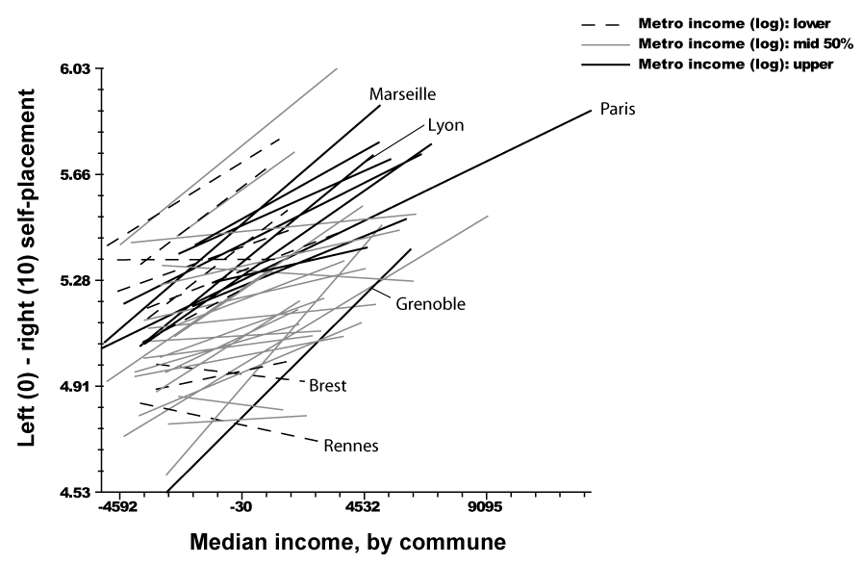

b) Higher education, by commune and by metropolitan average
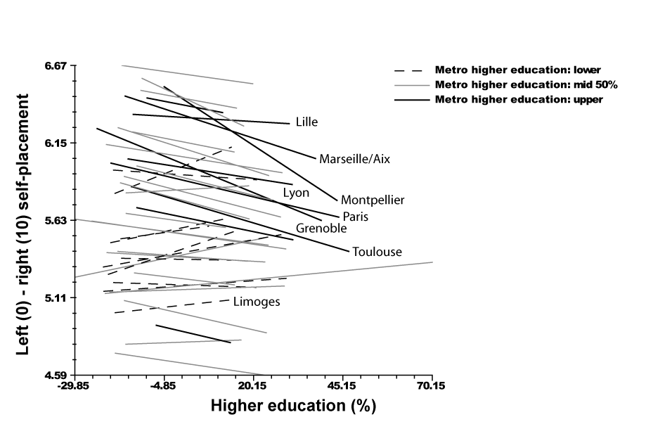

c) Per cent born abroad, by commune and by metropolitan area
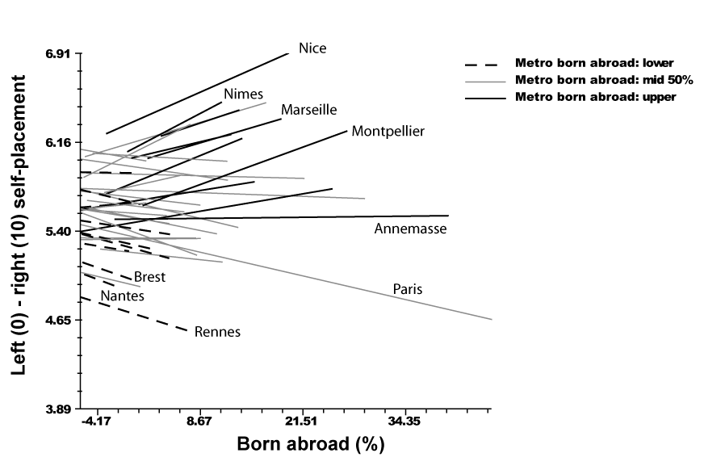
Table 5.7: Economic, cultural and globalisation indices
 | Economic index |  |  |  | Cultural index |  | Globalisation index
 | Full linear |  | Full randomised |  | Full linear |  | Full linear |  | Full randomised |  | Final randomised
 | B | t | B | t | B | t | B | t | B | t | B | t
Intercept | -0.088 | -0.10 | 5.159 | 319.94 | -0.481 | -0.41 | 1.649 | 0.79 | 5.108 | 214.77 | 5.070 | 168.49
Metro level
Eastern border region | 0.005 | 0.24 | 0.042 | 2.06 | 0.003 | 0.17 | 0.076 | 2.08 | 0.123 | 3.84 | 0.084 | 2.51
South | 0.040 | 1.47 | 0.080 | 3.37 | 0.047 | 1.36 | 0.056 | 0.90 | 0.113 | 2.99
Median income(log) | 1.354 | 5.90 |  |  | 1.450 | 4.71 | 0.922 | 1.68
Foreign-born | -0.002 | -0.96 |  |  | -0.001 | -0.40 | 0.012 | 2.03 |  |  | 0.013 | 3.57
Post-secondary education | -0.014 | -0.75 |  |  | -0.002 | -0.82 | -0.008 | -1.50
Cross-level
Post-secondary education |  |  | 0.000 | -3.33 |  |  |  |  | 0.000 | -3.62
Foreign-born |  |  | 0.001 | 3.75 |  |  |  |  | 0.000 | 3.01 | 0.001 | 3.62
Logauinc |  |  | 0.000 | 5.02 |  |  |  |  | 0.000 | 2.76
Local level
Post-secondary education | 0.003 | 5.52 | 0.011 | 4.48 | 0.003 | 9.87 | -0.006 | -18.27 | 0.002 | 1.07 | -0.005 | -17.14
Foreign born | 0.001 | 0.97 | -0.006 | -2.96 | 0.001 | 3.21 | 0.000 | -0.63 | -0.002 | -1.37 | -0.005 | -2.31
Age 60 or more | 0.004 | 8.50 | 0.004 | 11.62 | 0.004 | 11.53 | -0.001 | -2.16 | -0.001 | -1.66 | -0.001 | -1.94
Median income | 0.000 | 7.68 | -0.001 | -4.93 | 0.000 | 10.66 | 0.000 | 9.75 | 0.000 | -2.66 | 0.000 | 8.50
Unemployment | -0.003 | -2.60 | -0.002 | -4.44 | -0.003 | -6.87 | 0.001 | 2.81 | 0.002 | 3.60 | 0.001 | 2.33
Homeowners | 0.001 | 3.98 | 0.001 | 4.18 | 0.001 | 5.96 | 0.001 | 7.36 | 0.001 | 4.80 | 0.001 | 5.52
Noncommuters | 0.003 | 12.49 | 0.003 | 15.17 | 0.003 | 16.66 | 0.001 | 6.71 | 0.001 | 4.61 | 0.001 | 4.61
Residential stability | -0.001 | -3.56 | -0.001 | -7.30 | -0.001 | -5.79 | -0.001 | -6.14 | -0.001 | -5.90 | -0.001 | -5.92
Housing after 1975 | 0.000 | -0.58 | 0.000 | -1.16 | 0.000 | -1.06 | 0.000 | -1.32 | 0.000 | -1.68 | -0.003 | -2.01
Occupantional diversity | 0.000 | -0.01 | 0.011 | 0.57 | -0.002 | -0.13 | -0.051 | -2.51 | -0.053 | -2.58 | -0.049 | -2.41
Population (log)-logdens | -0.043 | -6.12 | -0.047 | -14.19 | -0.046 | -5.49 | -0.044 | -12.46 | -0.048 | -13.08 | -0.044 | -12.29
Chi-square |  | 1735 |  | 149.8 |  | 2376 |  | 4151 |  | 347.5 |  | 5190
D.f. (Metropolitan) |  | 36 |  | 39 |  | 36 |  | 36 |  | 39 |  | 39
(Local) |  | 6297 |  | 6297 |  | 6298 |  | 6298 |  | 6298 |  | 6300
p-value |  | 0 |  | 0 |  | 0 |  | 0 |  | 0 |  | 0
Reliability est. |  | 0.973 |  | 0.986 |  | 0.971 |  | 0.990 |  | 0.986 |  | 0.99
Local variance explained |  | 40% |  | 44% |  | 34% |  | 36% |  | 39% |  | 37%
Metro variance explained |  | 40% |  | -16% |  | 38% |  | 29% |  | 17% |  | 29%
Total variance explained |  | 40% |  | 27% |  | 36% |  | 33% |  | 28% |  | 33%
Estimator |  | 6024 |  | 6164 |  | 5459 |  | 5408 |  | 5496 |  | 5479
Notes: For boldface coefficients, p<.05.
As the town typology suggested, positions toward globalisation and cosmopolitanism departed from these consistent patterns. Although most of the variables retained a similar coefficient and significance as for the other indices, metropolitan income fell below statistical significance as a predictor of positions on the Globalisation Index. Instead, effects similar to the ‘racial threat’ hypothesis found in the U.S. literature accounted for most of the variation (e.g. Giles and Herz 1994; Lubbers and Scheepers 2002). With or without the other metropolitan-level variables, support for the ethnonationalist Right rose with the proportion of immigrants in a community. Opposition to globalisation and cosmopolitanism also concentrated among the socioeconomically disadvantaged communities where immigrants presented more direct economic competition to French workers. Unemployment, a strong determinant of Left voting in the other indices, reversed the sign of its coefficient to become a significant predictor of voting for the Right.
Additional tests demonstrated further effects from local and metropolitan influences. The distinct types of places highlighted in the town typology accounted for variations in partisan preferences even beyond what the full models of continuous variables could explain. Metropolitan constituencies clearly matter for the electoral coalition which has maintained the traditional French Right in power throughout the first decade of the twenty-first century. In 2002, the Right won support from communities similar to those that provided a critical margin to George W. Bush in the United States: Higher-income enclaves, low-density exurban communities, places with strong interests in protecting property assets and metropolitan areas with less educated electorates. These homogenous, low-density communities were the same ones that mobilised most consistently in local and national elections. If the moderate Left managed to retain support in the central cities and contest the middle-class suburbs, it remained confined to urban constituencies and service centres with concentrations of highly educated voters. The shift to the right on the Globalisation Index, evident in voting for the far left parties as well as the National Front, undermined support for the moderate Left in poor communities and in regions with higher immigration. In 2008, Nicolas Sarkozy drew from LePen’s bases of support to win a solid majority for Chirac’s party.

Conclusion
In France, metropolitan areas now shape both contemporary configurations of partisanship and patterns of political participation. If the shift toward neoliberal policy agendas with suburban backing has been less evident than in Anglo-Saxon countries, many of the same interests, value orientations and participatory trends have emerged from the metropolitan transformation.
As the networks of rural villages, that have dominated the French landscape since the Middle Ages, have become absorbed into expanding metropolitan regions, new territorial constituencies have emerged to reinforce majorities for the traditional French Right. Affluent localities and metropolitan regions now harbour the strongest support for market liberalism and traditional conservatism, as well as for economic and other forms of transnationalisation. Central cities, the most urbanised areas and centres of higher education serve as core constituencies for the culturally liberal, internationalist and moderate Left. Marginalised, disadvantaged suburbs and regions with recent histories of immigration, although still close to the Left on other economic and cultural issues, proved to be susceptible to the appeals of the extreme right, anti-immigrant National Front in 2002. These metropolitan variations in partisanship are more than simply accidents of demographic composition. Influences from community characters account for variations in partisan preferences which demography cannot, and provide alternative or partial explanations for another portion. Even such demographic predictors of partisanship as income and education differ in their effects according to the contexts of different metropolitan regions.
Among the determinants of electoral participation, influences rooted in similar metropolitan contexts across the country now largely overwhelm regional differences as well. Differences in community characteristics are especially powerful predictors of voter turnout in municipal elections, and also influence national election turnout. In the low-density, lower income and middle class communities of metropolitan peripheries, rural clientelist and participatory traditions continue to promote higher, more uniform rates of electoral participation. Patterns of electoral mobilisation have favoured the low density, more homogenous localities where the Right performed the best. Homeownership and lower settlement density have promoted both local participation and national mobilisation. By contrast, metropolitan electoral demobilisation has most often disadvantaged the urbanised, diverse and disadvantaged strongholds of the Left. In socioeconomically stressed localities and dense urban concentrations, local participation also falls significantly below participation in national elections. Although affluent communities and larger metropolitan regions have disengaged from local elections, these areas mobilised nationally to maintain the traditional Right in power. Metropolitisation has decisively shaped patterns of electoral participation in France.

Bibliography
Abrial, S., Cautrès, B. and Mandran, N. (2003) Turnout and abstention at multi-level elections in France, Working Paper, Centre d’Informatisation des Données Socio-Politiques, Grenoble, France.
Blais, A. (2004) ‘Where does turnout decline come from?’, European Journal of Political Research, Vol. 43 Issue 2 (March): 221-236.
Bréchon, P. and Cautrès, B. (1987) ‘L’inscription sur les listes électorales: indicateur de socialisation ou de politisation’, Revue Francaise de Science Politique 37 (4): 502-525.
Campbell, D. (2006) Why We Vote. Princeton: Princeton University Press.
Cavailhès, J., Peeters, D., Sékeris, E. and Thisse, J.-F. (2002) La Ville périurbaine, Université de Franche-Comté, Centre d’économie et sociologie appliquées à l’agriculture et aux espaces ruraux, Working Paper.
Chalard, L. (2006) ‘Le vote d’extrê, e droite dans l’aire métroplitaine marseillaise’, Espaces-temps.net, retrieved August 23, 2008 at http://espacestemps.net/document2101.html.
Clanché, F. (2003) ‘La participation électorale au printemps 2002. De plus en plus de votants intermittents’, INSEE-Première, janvier, n°877: 1-4.
Clark, T.N. and Hoffmann-Martinot, V. (eds.) (1998) The New Political Culture, Boulder: Westview.
Dalton, R. (2008) Citizen Politics, Washington, DC: Congressional Quarterly Press.
Fischel, W.A. (2001) The Homevoter Hypothesis, Cambridge, MA: Harvard University Press.
Flanagan, S. (1980) ‘National and Local Voting Trends: Cross-level Linkages and Correlates of Change’, in Steiner, K., Krauss, E.S. and Flanagan, S. (eds.) Political Opposition and Local Politics in Japan, Princeton: Princeton University Press: 131-184.
Frandsen, A.G. (2002) ‘Size and electoral participation in local elections’, Environment and Planning C: Government and Policy, Vol. 20 (6) December: 853 – 869.
Gilderbloom, J.I. and Markham, J.P. (1995) ‘The Impact of Homeownership on Political Beliefs’, Social Forces, 73, 1589-1607.
Giles, M.W. and Hertz, K. (1994) ‘Racial Threat and Partisan Identification’, American Political Science Review, Vol. 88 (2): 317-326.
Gimpel, J.G., Morris, I.L. and Armstrong, D.R. (2004) ‘Turnout and the local age distribution: examining political participation across space and time’, Political Geography, Jan., Vol. 23, 1: 71-95.
Goerres, A. (2005) ‘Grey Voting Power on the Rise? How the transition from middle to old age influences turnout in Europe’, Paper presented at the 55th Political Studies Association Annual Conference, 4-7 April 2005, University of Leeds, 28 p.
Hoffmann-Martinot, V. (1992) ‘La participation aux élections municipales dans les villes françaises’, Revue Francaise de Science Politique 42 (1): 3-35.
Hoffmann-Martinot, V. (2005) ‘Towards an Americanization of French Metropolitan Areas?’ in Hoffmann-Martinot, V. and Sellers, J.M. (eds.), Metropolitanization and Political Change, Wiesbaden: Verlag für Sozialwissenschaften.
Hoffmann-Martinot, V., Rallings, C. and Thrasher, M. (1996) ‘Comparing local electoral turnout in Great-Britain and France: More similarities than differences?’, European Journal of Political Research, 30. September 1996: 241-257.
Julien, P. (2003) ‘L’évolution des périmètres des aires urbaines 1968-1999’ in Pumain, D. and Mattei, M.-F. (eds.) Données urbaines 4 Paris: Anthropos: 11-20.
Kesselman, M. (1967) The ambiguous consensus; a study of local government in France, New York: Knopf.
Kingston, P.W., Thompson, J.L.P. and Eichar, D.M. (1984) ‘The Politics of Homeownership’, American Politics Quarterly, 12 (2), April: 131-150.
Kitschelt, H. (1994) The Transformation of European Social Democracy, Cambridge University Press.
Kitschelt, H. (1996) The Radical Right in Western Europe: A Comparative Analysis. Ann Arbor: University of Michigan Press.
Kriesi, H., Grande, E., Lachat, R., Dolezal, M., Bornschier, S. and Frey, T. (2006) ‘Globalization and the transformation of the national political space: Six European countries compared’, European Journal of Political Research 45: 921-956.
Laakso, M. and Taagepera, R. (1979) ‘Effective Number of Parties: A Measure with Application to Western Europe’, Comparative Political Studies 12: 3-27.
Lidström, A. (2005) ‘Commuting and citizen participation in Swedish city-regions’, Political Studies, Vol. 54, Issue 4: 865–888.
Lubbers, M. and Scheepers, P. (2002) ‘French Front National voting: a micro and macro perspective’, Ethnic and Racial Studies 25 (1): 120-149.
Morlan, R.L. (1984) ‘Municipal vs. national election voter turnout: Europe and the United States’, Political Science Quarterly, 99: 457- 470.
Nevers, J.-Y. 2002) ‘Electoral Participation and Local Democracy in French Rural Areas’, Paper Presented at American Political Science Association Annual Meeting, Chicago, IL.
Niemi R.G. and Barkan, J.D. (1987) ‘Age and Turnout in New Electorates and Peasant Societies’, The American Political Science Review, Vol. 81 No. 2 June: 583-588.
Oliver, J.E. (2000) ‘City Size and Civic Involvement in Metropolitan America’, The American Political Science Review, Vol. 94 No. 2 June: 361-373.
Oliver, J.E. (2001) Democracy in Suburbia, Princeton: Princeton University Press.
Péguy, P.-Y. (2000) Analyse économique des configurations urbaines et de leur étalement, Ph.D dissertation, Université de Lyon.
Putnam, R. (2000) Bowling Alone, New York: Touchstone.
Rosenstone, S.J. (1982) ‘Economic Adversity and Voter Turnout’, American Journal of Political Science, Vol. 26 No. 1 February: 25-46.
Siegfried, A. (1913) Tableau politique de la France de l’Ouest sous la Troisième République. Paris: Armand Collin.
Squire, P., Wolfinger, R.E. and Glass, D.P. (1987) ‘Residential Mobility and Voter Turnout’, The American Political Science Review, Vol. 81 No. 1. March: 45-66.
Tiberj, V. (2004) ‘Vers une citoyenneté plurielle? Le rôle de l’origine ethnique dans l’intégration politique des 15-24 ans’, Paris: Notes et Etudes du CEVIPOF, 43 p. http://www.cevipof.msh-paris.fr/publications/ notes_etudes/VT_ehnicit.pdf
Verba, S. and Nie, N.H. (1972) Participation in America: Political Democracy and Social Equality, New York: Harper & Row.

Appendix
Table A.5.1: Independent variables
Eastern border region | Location in eastern border region (1,0)
South | Location in region along Mediterranean Sea or Spanish border (1,0)
Post-secondary education | Per cent of adult population with baccalaureate or higher education, 1999
Foreign-born | Per cent of population born abroad, 1999
Population (log) | Metropolitan population (logged), 1999
Age 60 or more | Per cent of population aged 60 or more, 1999
Median income | Median per capita communal income, 1999
Unemployment | Per cent of workforce unemployed, 1999
Homeowners | Per cent of households owning primary residence, 1999
Noncommuters | Per cent of workers not commuting to another commune to work, 1999
Residential stability | Per cent of, 1999
Housing after 1975 | Per cent of primary residences built after 1975, 1999
Occupantional diversity | Simpson index of three occupational groups (see footnote x), 1999
Population density (log) | Persons per square kilometre (logged), 1999
Political diversity | Political diversity index, Presidential first round Partisan fragmentation/homogeneity, Presidential first round election 2002 (Laakso-Tagapera index)
Population 2500-3500 | Communes with voter choice of candidates on list (Communal population 2500 to 3500, 1999)
Population under 2500 | Communes with no requirement of a party list (Communal population under 3500, 1999)

For the precise procedures used see the Methodological Appendix to this volume.
In contrast to the United States, low density suburbs have not generally been the fastest growing. For this reason, density alone rather than a combination of density and growth rates were used to classify this group.
Rates of post-secondary education correlate significantly more positive with foreign-born populations, residential mobility, and with unemployment. Median income correlates negatively with the presence of children and with homeownership, while education rates bear no significant relation to these indicators. Although similar variations mark the two highly correlated age categories (-.72, p<.001), the indicator for young children was eliminated after regressions showed it to have no independent effect alongside the indicator for residents over 60 years old.
Homeownership correlated at -.48 (p<.01) with foreign-born populations and -.45 (p<.01) with unemployment. As the typology suggests, denser communities feature smaller proportions of homeowners (-.56, p<.01) and more foreign-born residents (.44, p<.01). Indicators of mobility and new housing correlated significantly but usually modestly with each other and with the other indicators. Finally, communes with populations fewer than 3500 and fewer than 2500 were governed by distinctive rules for local elections that affect participation. Although dichotomous indicators for these contextual effects inevitably correlated with population density (-.71, p<.01), further analysis will show additional effects from these rules that density alone cannot explain.
In the first round, all candidates appear on the ballot. Should no candidate win a simple majority in this round, a second round pits the leading candidates from the first round against each other.
See this table and all other web appendixes of this chapter in the following web folder: www.ecprnet.eu/ecprpress/WA05hoffmann-martinot_sellers.
Note that the variables, in fact, measure non-commuting and residential stability; hence the negative values.
Both regressions of the town types along with the full ordinary least squares models, and further tests of the types against the residuals from the full hierarchical linear models, confirm these effects (Tables WA.5.1, WA.5.2 WA.5.4).
See the methodological appendix to this volume for the questions used to compile these indices.
Linear variables at metropolitan levels were again selected from a larger group of variables by backwards regression, supplemented by tests of permutations for the best alternative model that could be applied consistently for the various indices.
Ordinary least squares results (Appendix A.5.4) demonstrated the significance of regional and metropolitan as well as local variations, but did not permit an examination of the relationships between these different levels of explanation.
Both the full linear regressions and the models with other compositional variables confirmed a significant bivariate correlation (.255, p < .01).
The one clear exception is the border metropolis of Annemasse-Geneva, where longstanding links to Switzerland have fostered a cosmopolitan local culture
Both ordinary least squares models and models of residuals from the multilevel models demonstrate these additional effects (Tables WA.5.3, WA.5.4). Affluent suburbs, low density suburbs and also high poor minority suburbs each provide significantly stronger support for the Right along the economic and cultural dimensions as well as Left-Right self-placement. Residuals from the multilevel linear regressions for the globalisation index points to an even stronger contextual effect in the hardship minority and low density suburbs. Both types of communes registered significantly stronger support for the Right. Although the affluent suburbs had provided stronger support for the economic and cultural indices of voting for the Right, no such support appeared for the rightist position on the globalisation index.

